CA ASSIGNMENT LAB – 05

**BOMB LAB**

**BOMB ID: 207**

**BOMB LAB CONSISTS 6 PHASES**

In each phases we use GDB debugger and we find the logic and find the required values for each phases.

**Command for using GDB is:**

**gdb bomb**

Phase 1: 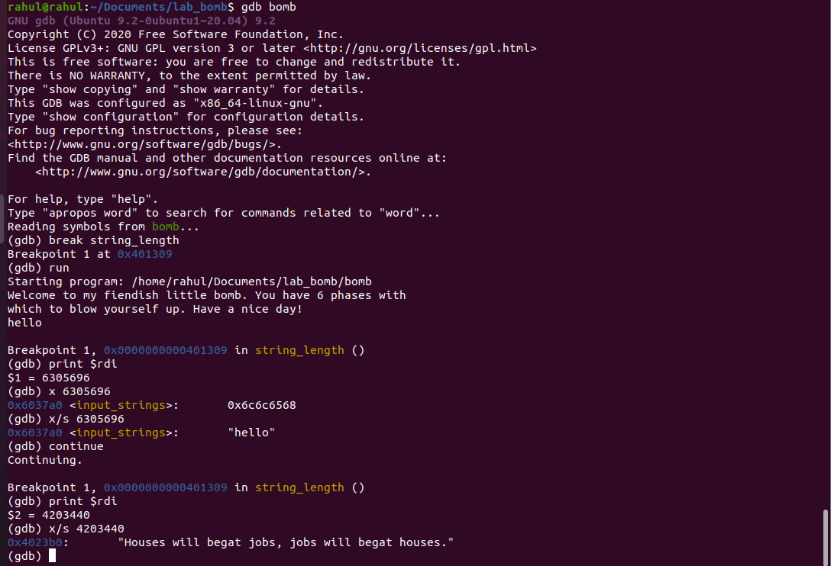

Phase 1 process:

By analyzing code we can say that required answer is string

1. Use GDB bomb.

2. Break at string_length.

3. Run the program and give input as hello.

4. Print $rdi and use x/s for the value, we get hello.

5. Now at another break point we get the required value.

**Final value in phase 1 is :**

**“Houses will begat jobs, jobs will begat houses.”**

**Phase 2:**

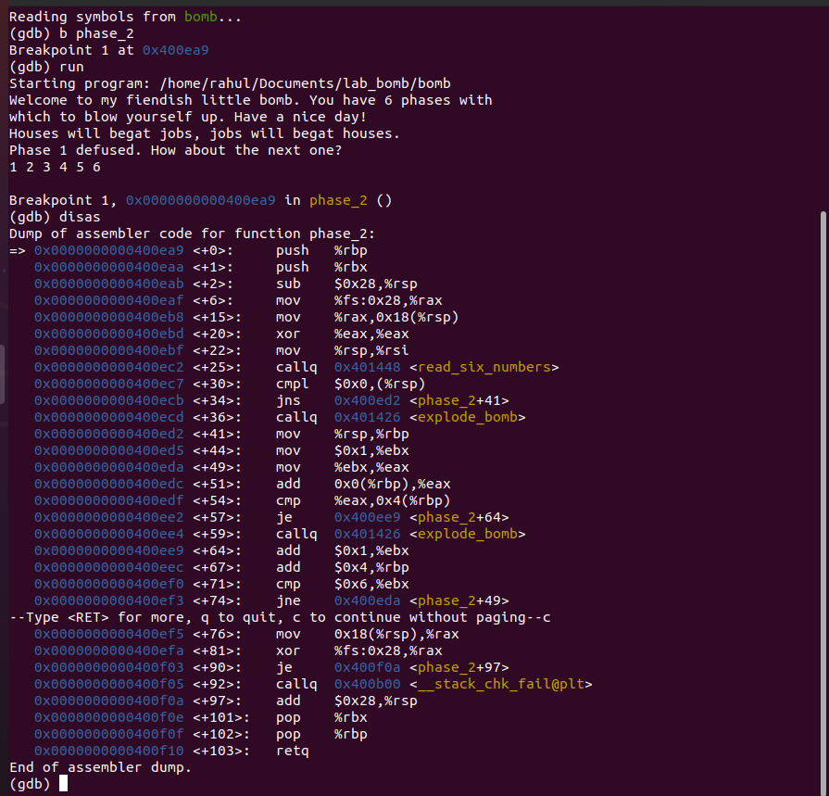

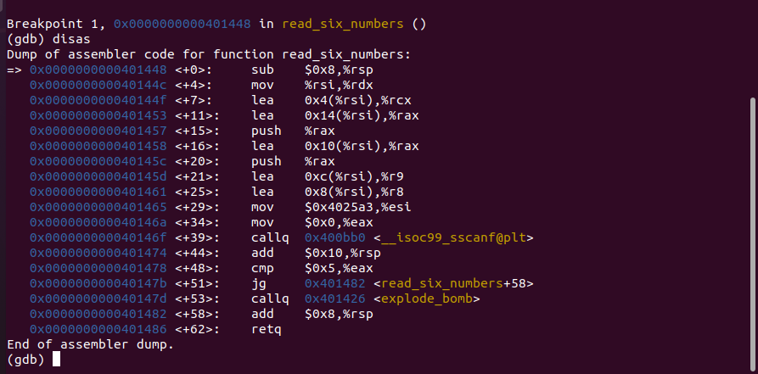

This phase is solved by just analyzing the code

By assembly language knowledge we can get the required answer for phase 2.

**Process for phase 2:**

1. By analyzing code we know that there are six numbers and the starting number is 1

2. For the next five number in a sequence some value is added

3. For second number one is added to the previous number

4. For third number two is added to the previous number

5. For fourth number three is added to the previous number

6. For fifth number four is added to the previous number

7. For last (sixth) number five is added to the previous number

**Finally the answer for phase 2:**

**1 2 4 7 11 16**

Phase 3:

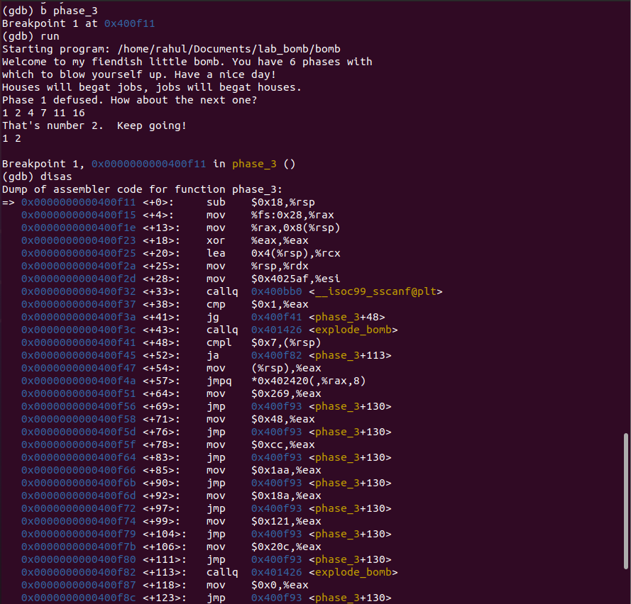

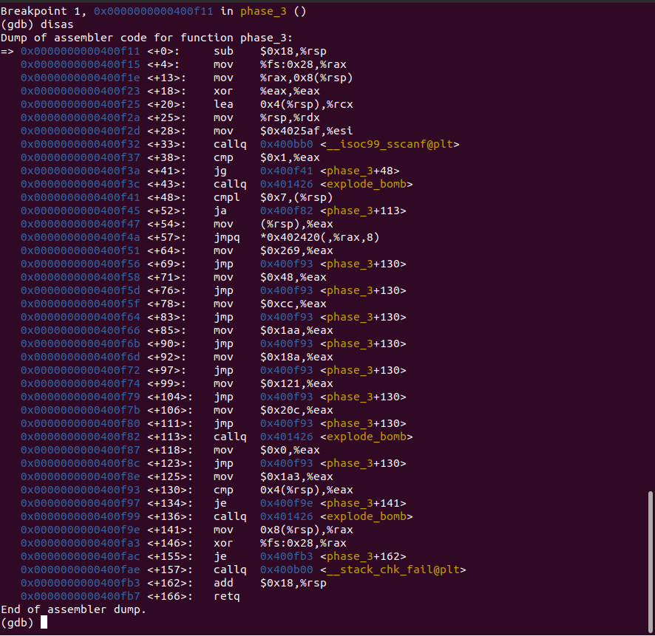

**Process for phase 3:**

1. This phase contains switch statements
2. This phase contains two integers by using x/s 0x4025af

C:\Users\Rahul Varma\Desktop\Screenshot 2021-10-09 180739.png

1. By seeing code we can analyze

C:\Users\Rahul Varma\Desktop\Screenshot 2021-10-09 180114.png

1. And by seeing appropriate switch case we can get the final values
2. By considering the first value as 4

and calculating the next value by seeing the above code(last page) and converting into binary we get 426

**The final value for phase 3 is:**

**4 426**

Phase 4:

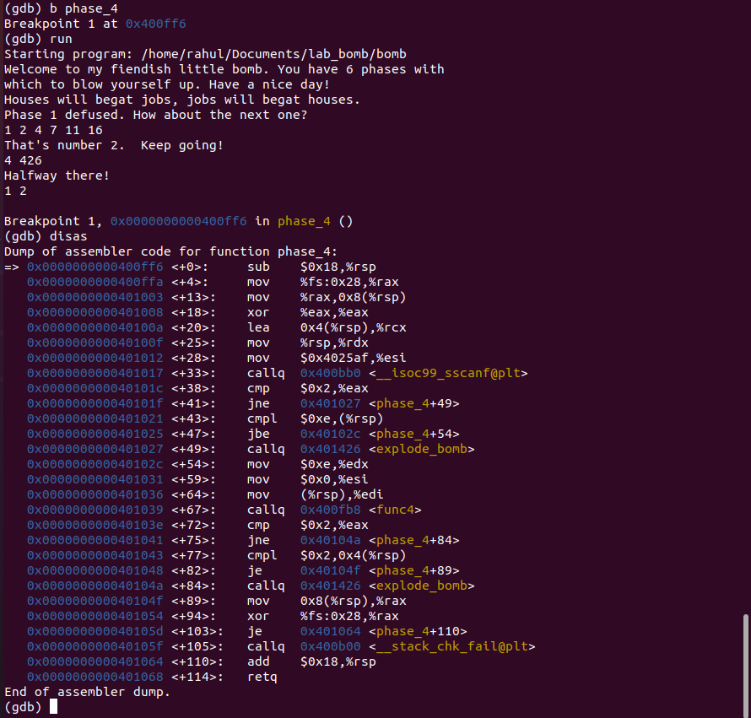

Process for phase 4:

1.This phase contains two integers

C:\Users\Rahul Varma\Desktop\Screenshot 2021-10-09 181541.png

2.By the below picture we can analyze that first integer lies between 1 and 14

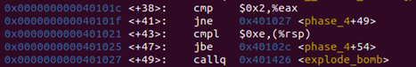

3.By the below photo we can analyze that the second integer is 2

C:\Users\Rahul Varma\Desktop\Screenshot 2021-10-09 181900.png

4. By keeping value for first integer from 1 to 14 by keeping second integer 2, we can get the first integer as 4

**The final answer for phase 4 is:**

**4 2**

Phase 5: 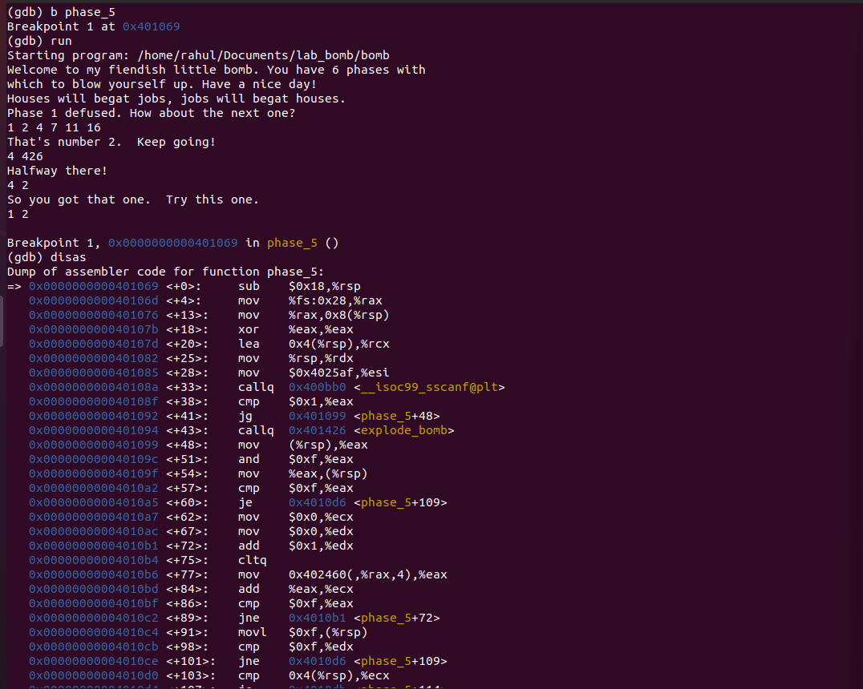

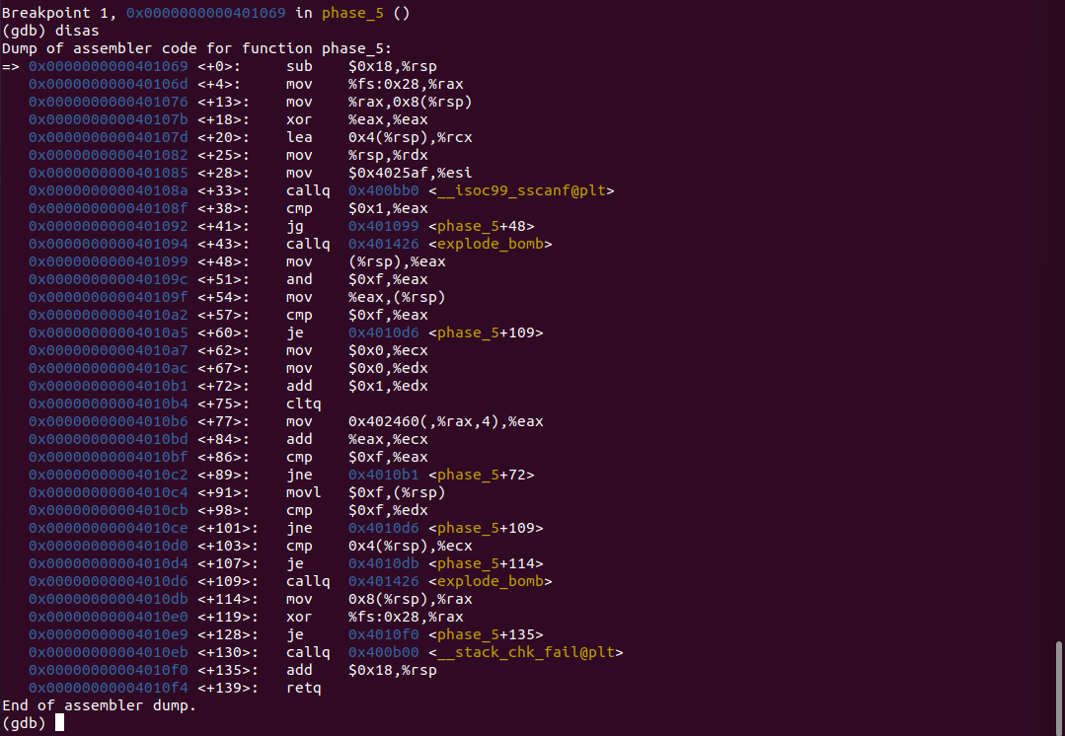

Process for phase 5:

1.This phase also consists two integers (as we checked in phase 3 and 4)

2.This is like a switch function

3. First make break point at phase_5 and run next each instruction one by one by using (nexti) instruction

4. Analyzing each and every line one by one

and seeing each register values by using info r

5.By considering the first value as 5 we can get the second value as 115

**The final answer for phase 5:**

**5 115**

Phase 6: 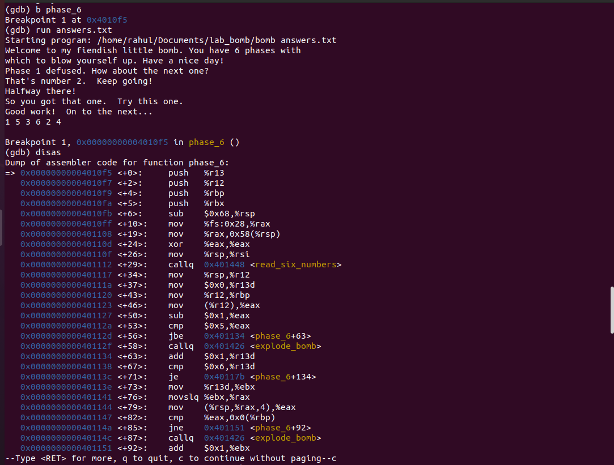

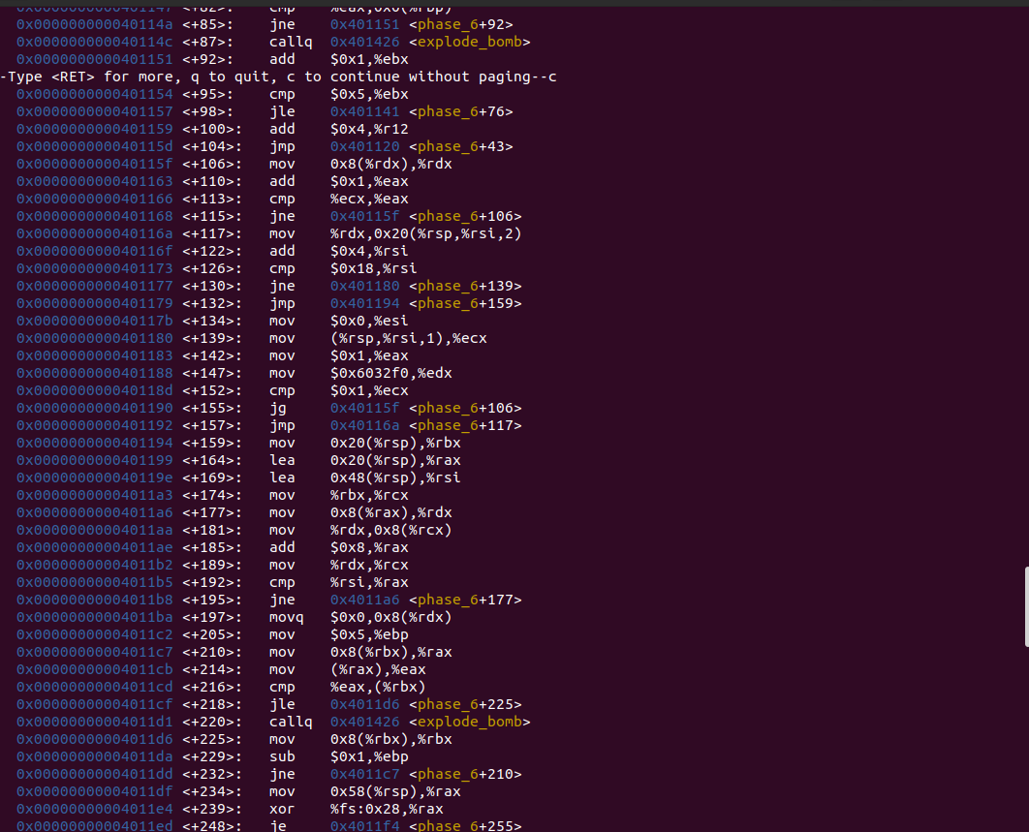

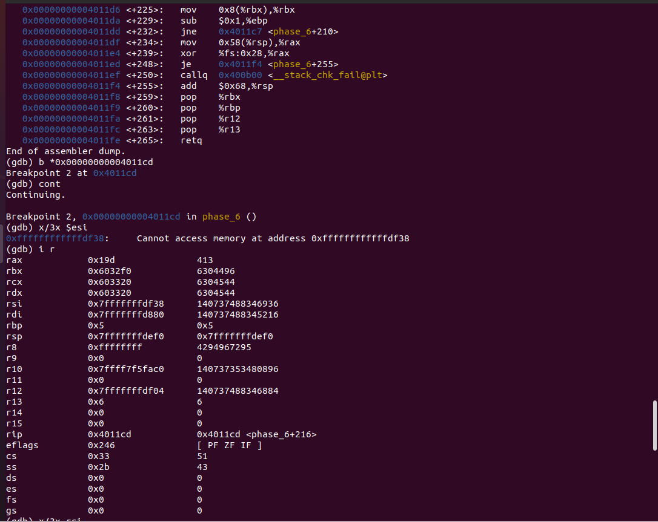

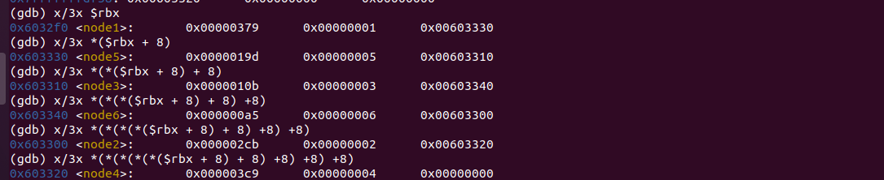

Process for phase 6:

1. Set first break point and by using (disas) analyze the code

And in this phase consists 6 numbers and not repeating.

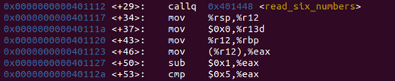6 numbers

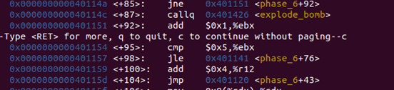Not repeating

2.By considering the break point at (4001cd)

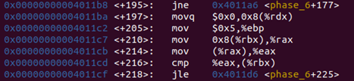

C:\Users\Rahul Varma\Desktop\Screenshot 2021-10-09 183456.png

3.By finding values at each memory

And converting these left most values to binary values we get

Node1:889

Node5:413

Node3:267

Node6:165

Node2:715

Node4:969



According to the above picture (jle) in the last line

We should keep order of the nodes from smallest to highest

Nodes values (6 <3 <5 <2 <1 <4)

So the required value is 6 3 5 2 1 4

The final answer for phase 6 is:

6 3 5 2 1 4

The final input for 6 phases are :

Phase 1: Houses will begat jobs, jobs will begat houses.

Phase 2: 1 2 4 7 11 16

Phase 3: 4 426

Phase 4: 4 2

Phase 5: 5 115

Phase 6: 6 3 5 2 1 4

THANK YOU